REQUIREMENT REVIEWS & INSPECTIONS

Module Name: E-Commerce Website - Product & Cart Module Test Case
Test Case ID: TC001
Tester Name: Chouhan Himansu Raj Singh

Test Scenarios :
● Scenario ID: 1a
Scenario: View products on the home page
Test Steps:
1. Open the DemoBlaze website
2. Wait for the home page to load
3. Observe the product list
Screenshots:
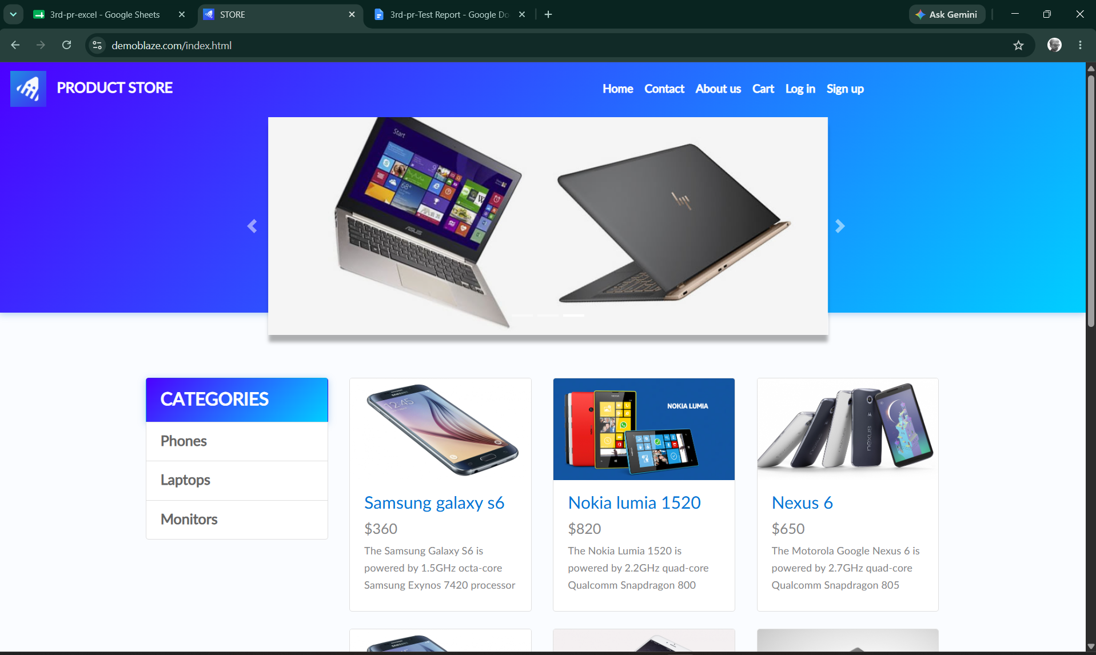

● Scenario ID: 1b
Scenario: Select a product from the list
Test Steps:
1. Open the DemoBlaze website
2. View product list
3. Click on a product name
Screenshots: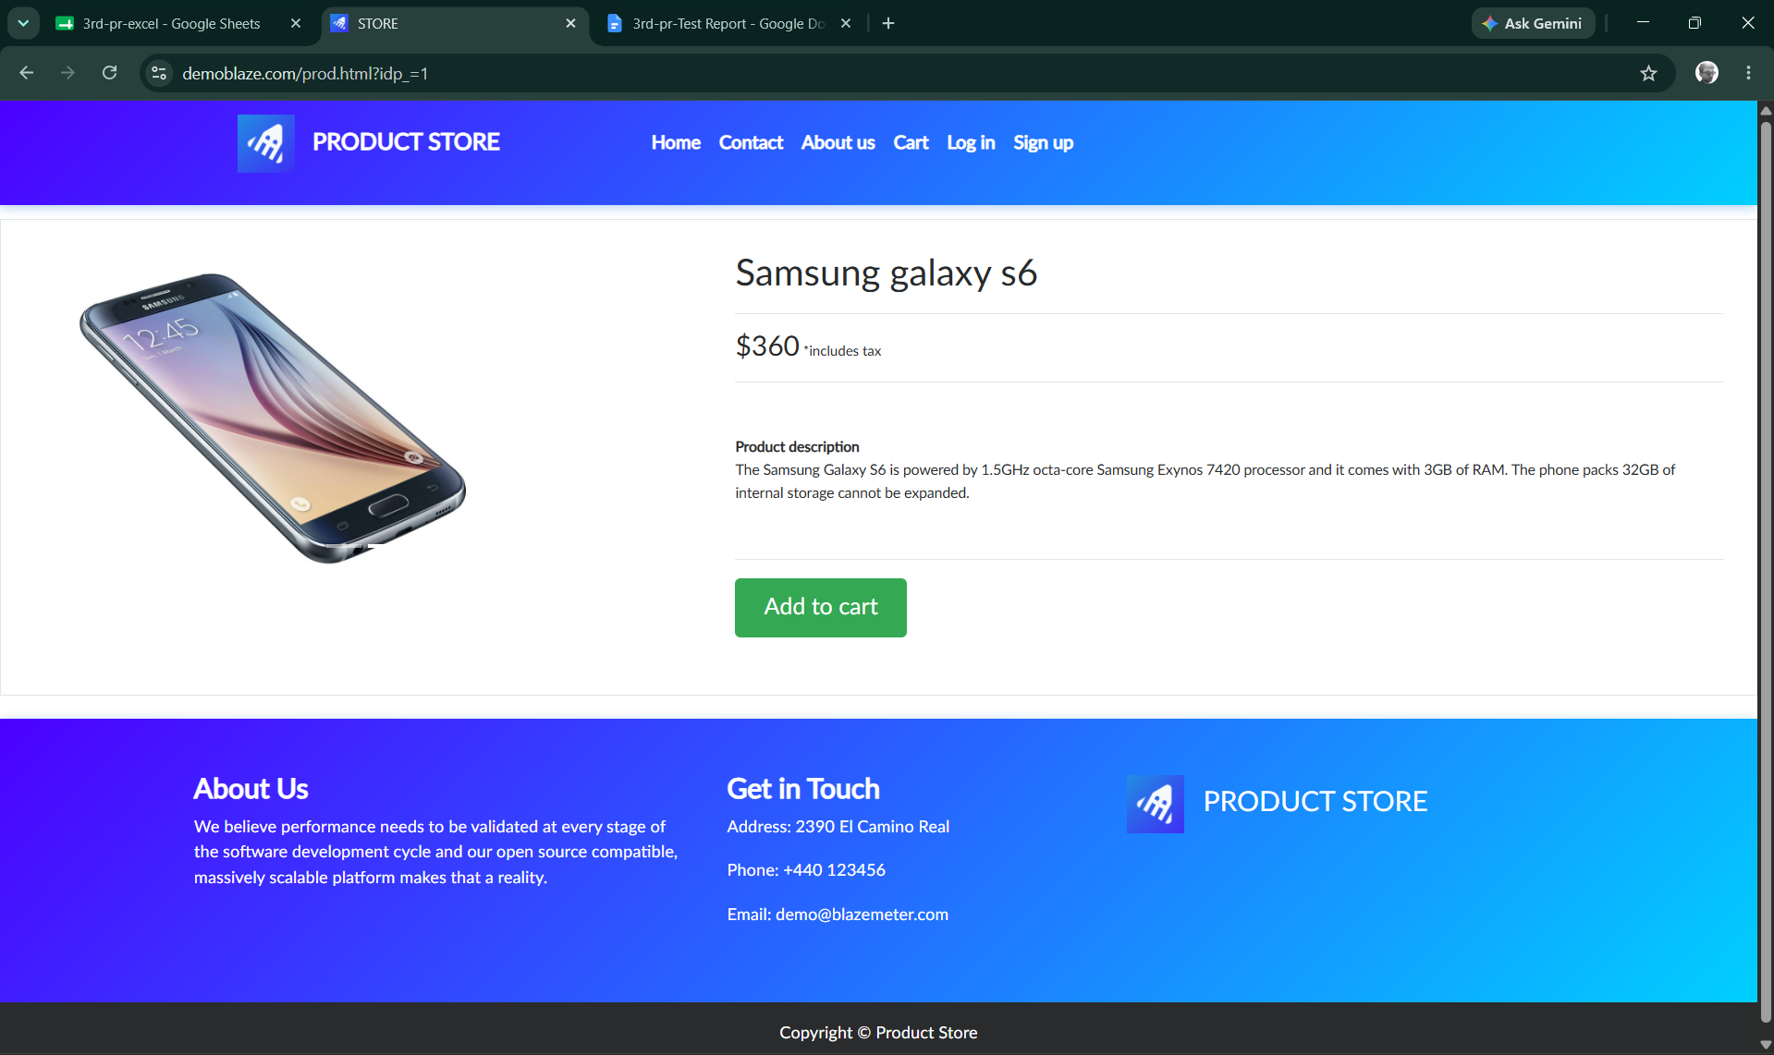
● Scenario ID: 1c
Scenario: View product details
Test Steps:
1. Open the DemoBlaze website
2. Select a product
3. Observe product name, price, and description
Screenshots:
● Scenario ID: 1d
Scenario: Add product to cart
Test Steps:
1. Open the DemoBlaze website
2. Select a product
3. Click 'Add to cart' button
Screenshots: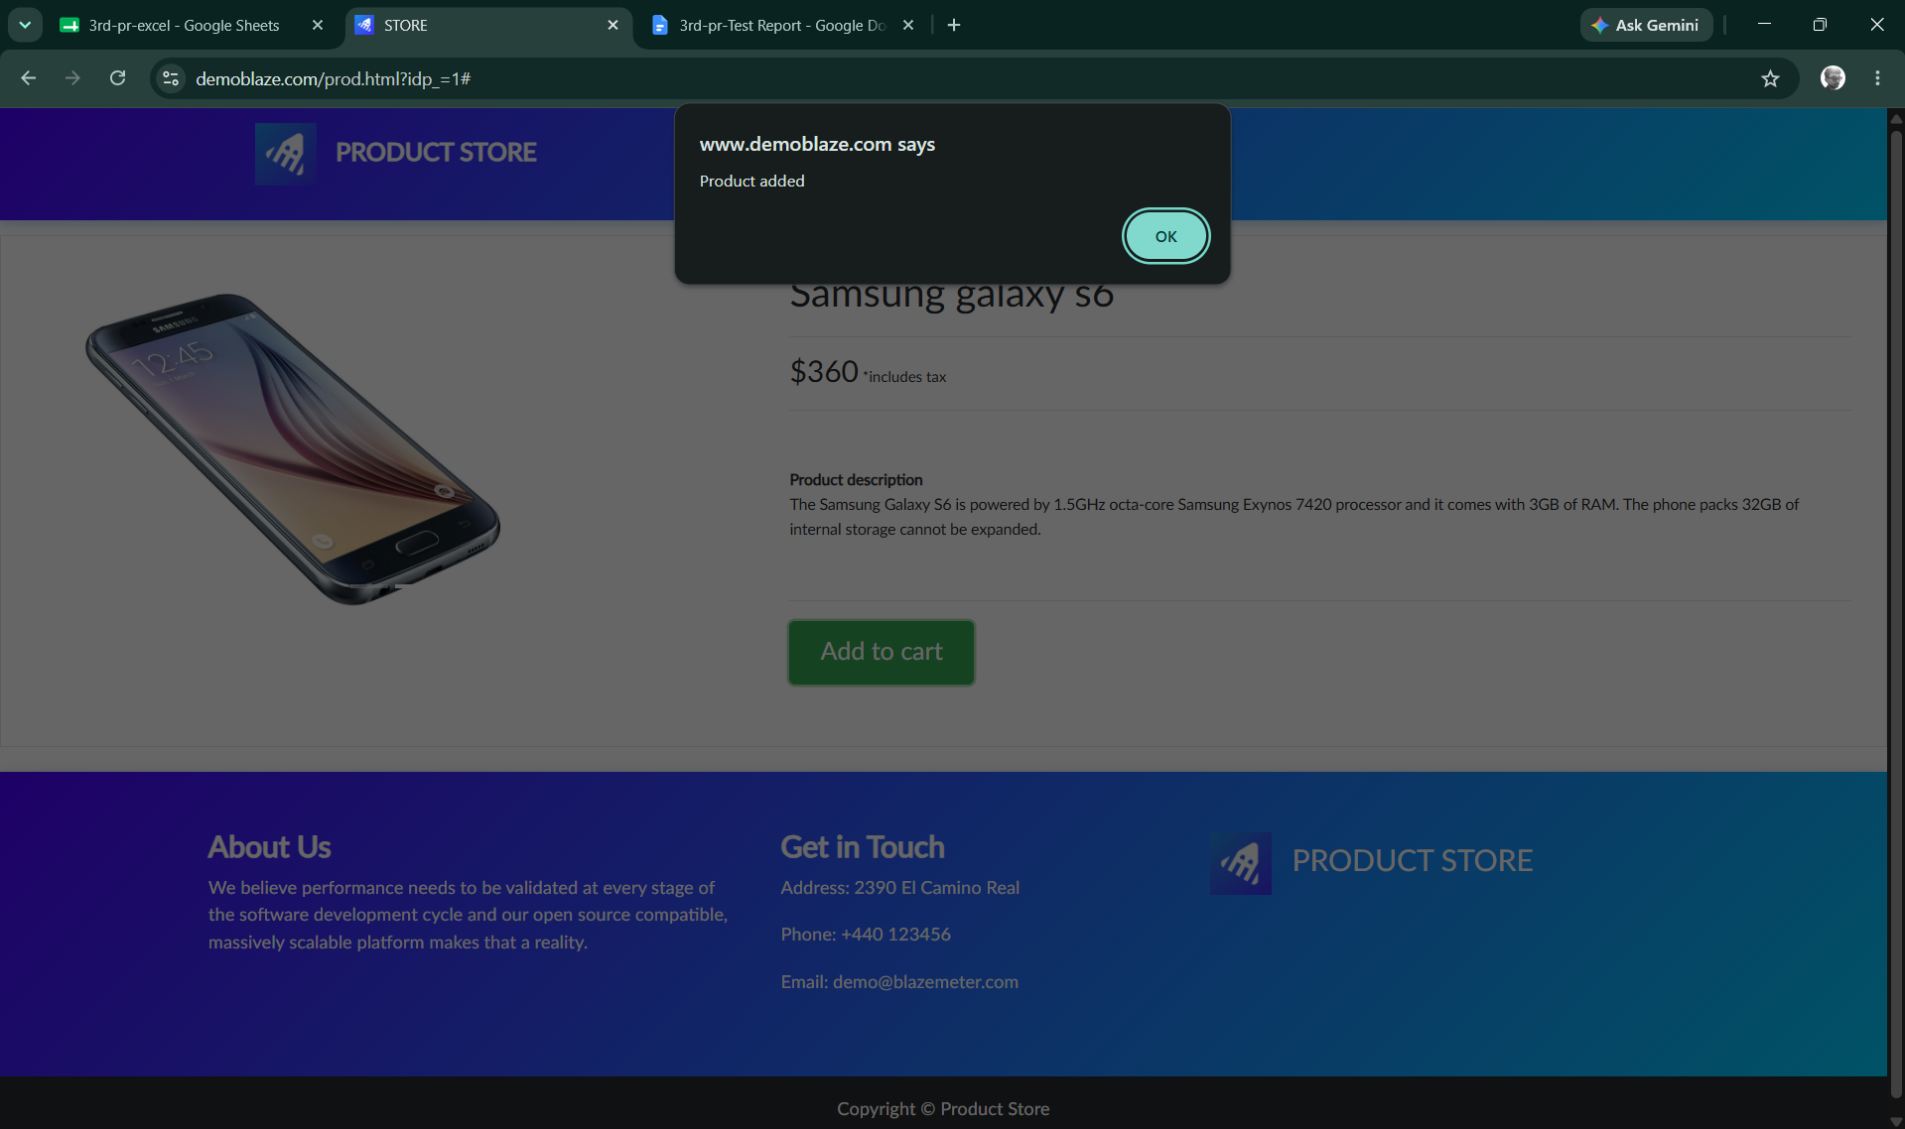

● Scenario ID: 1e
Scenario: Open cart
Test Steps:
1. Open the DemoBlaze website
2. Add a product to cart
3. Click 'Cart' navigation link
Screenshots: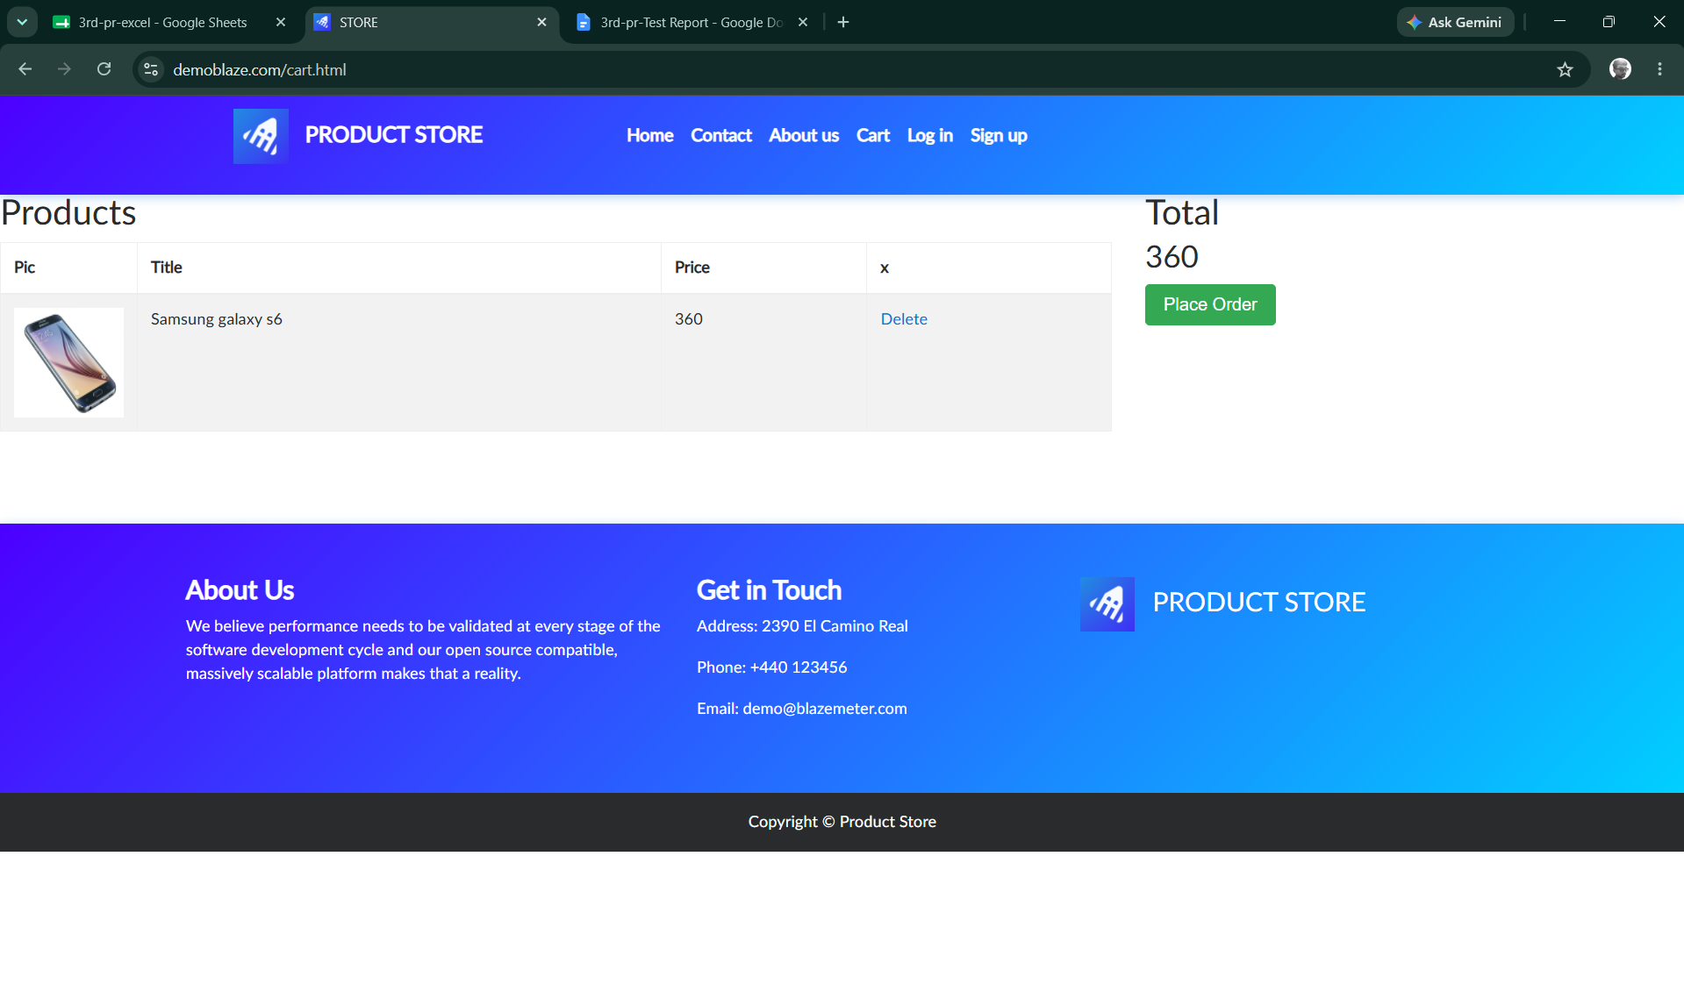
● Scenario ID: 1f
Scenario: Verify product in cart
Test Steps:
1. Open the DemoBlaze website
2. Add a product to cart
3. Open the cart
4. Verify product name and price
Screenshots:
● Scenario ID: 1g
Scenario: Remove product from cart
Test Steps:
1. Open the DemoBlaze website
2. Add a product to cart
3. Open the cart
4. Click 'Delete' next to the product
Screenshots: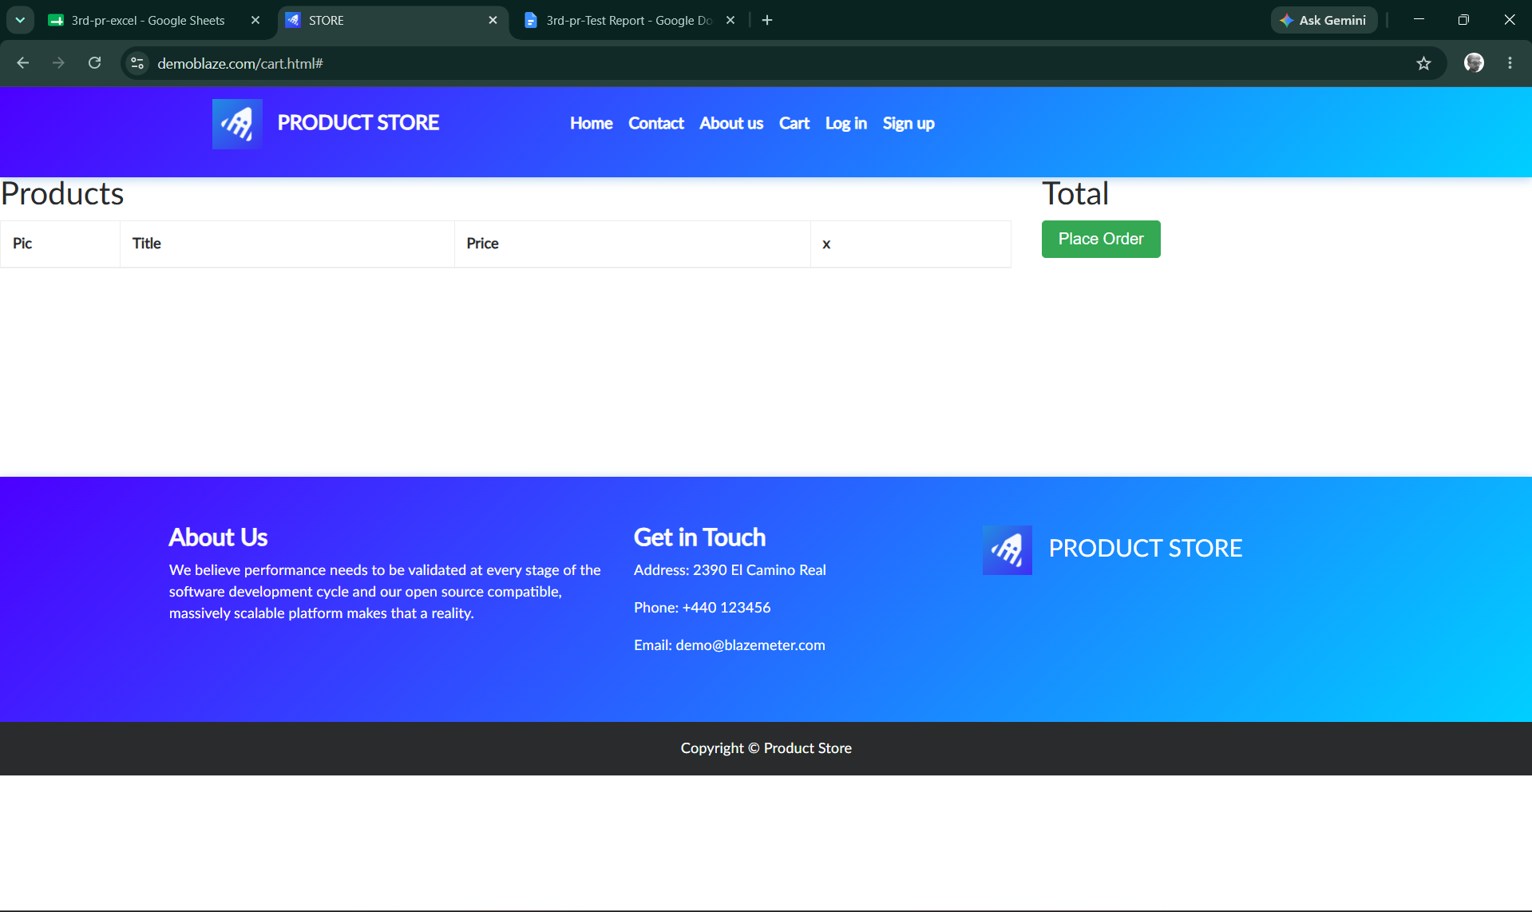

Summary of Test Results:
Total Test Cases | 7
Passed | 7
Failed | 0
Not Executed | 0
Pass Rate (%) | 100%

Conclusion and Recommendations

Conclusion
All 7 test scenarios for the E-Commerce Website Product and Cart Module have been executed successfully with a 100% pass rate. The product browsing, add-to-cart, cart verification, and remove-from-cart functionality worked as expected across all test cases. The actual results matched the expected results in every scenario, indicating that the Product and Cart Module is functioning correctly and reliably for the tested workflows.

Test Coverage Analysis
● Product listing display - PASSED
● Product selection and navigation - PASSED
● Product detail accuracy - PASSED
● Add-to-cart functionality - PASSED
● Cart page display - PASSED
● Cart content verification - PASSED
● Remove-from-cart functionality - PASSED
● The Product and Cart Module is ready for deployment to production with the current functionality.
● Consider adding quantity selection when adding a product to the cart.
● Add validation to prevent duplicate cart entries or clearly display quantity for repeated adds.
● Implement cart persistence across sessions using cookies or local storage.
● Add automatic cart total recalculation with clear tax/shipping breakdown.
● Test with a larger and more varied product catalog, including out-of-stock items.
● Add error handling for network failures during add-to-cart or checkout actions.
● Conduct performance testing under load to ensure the product and cart pages scale appropriately.
● Test cart behavior across multiple browser tabs and concurrent sessions.
● Regular regression testing should be scheduled after any catalog or pricing updates.

Bug Reports
Summary: No bugs identified during the execution of the 7 test scenarios. All tests passed with expected results matching actual results.

